10/9/2024

**Uzair Ali S/O Yar Muhammad Memon**

**B-S CS III Section A**

**023-23-0350**

**T0: Ma’am Marina Rajpoot**

Data Structures

Lab 7 Exercise Solutions

**Task #1**

1. Write a program to ask user input N and print numbers from 1 – N in ascending/descending order using recursion.

**Solution:**

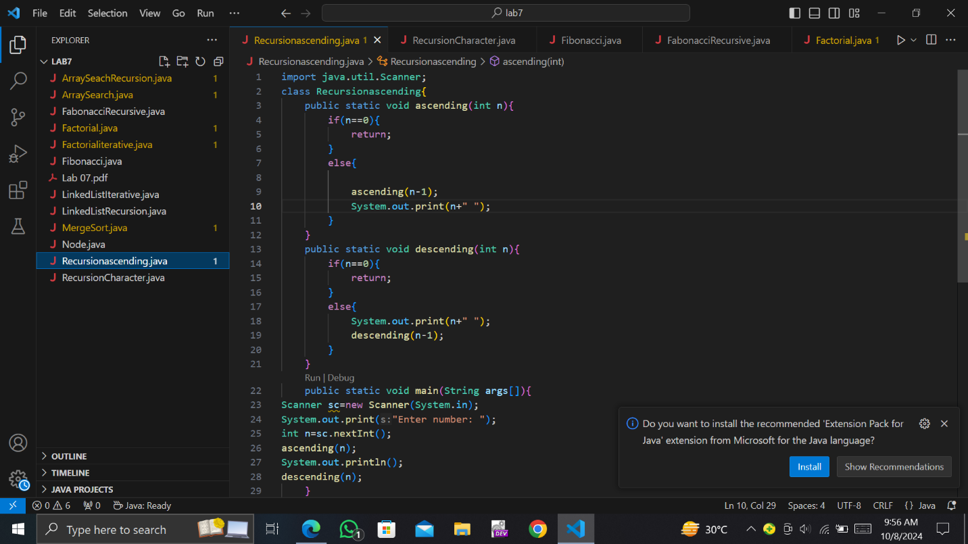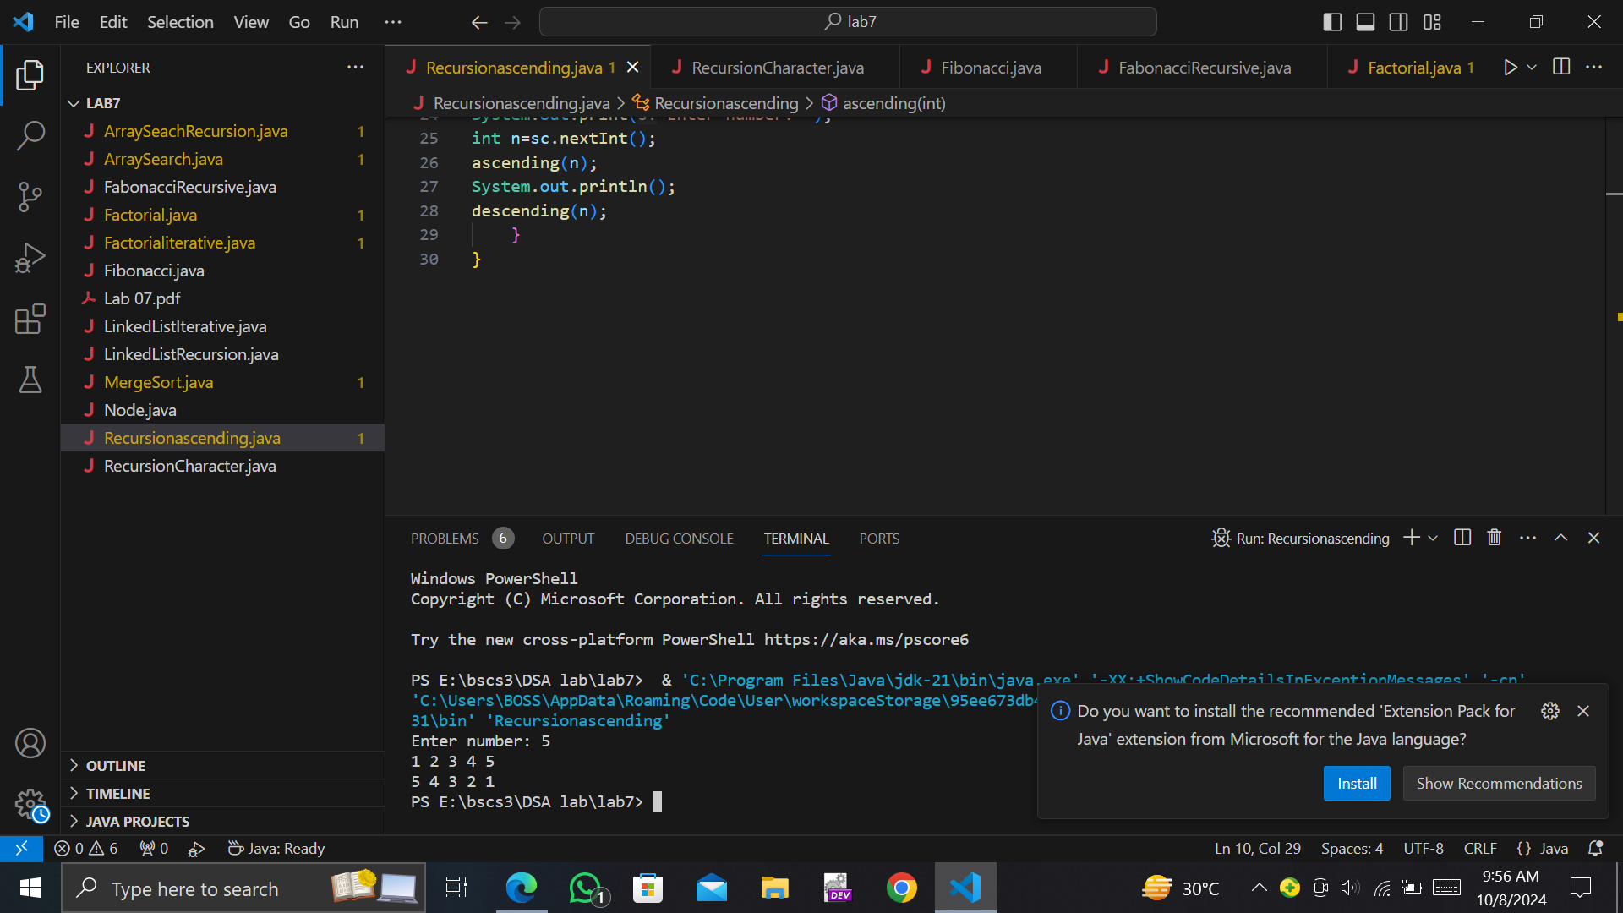

**Task #2**

. Print 1d character array values using recursion in forward/reverse direction.

**Solution:**

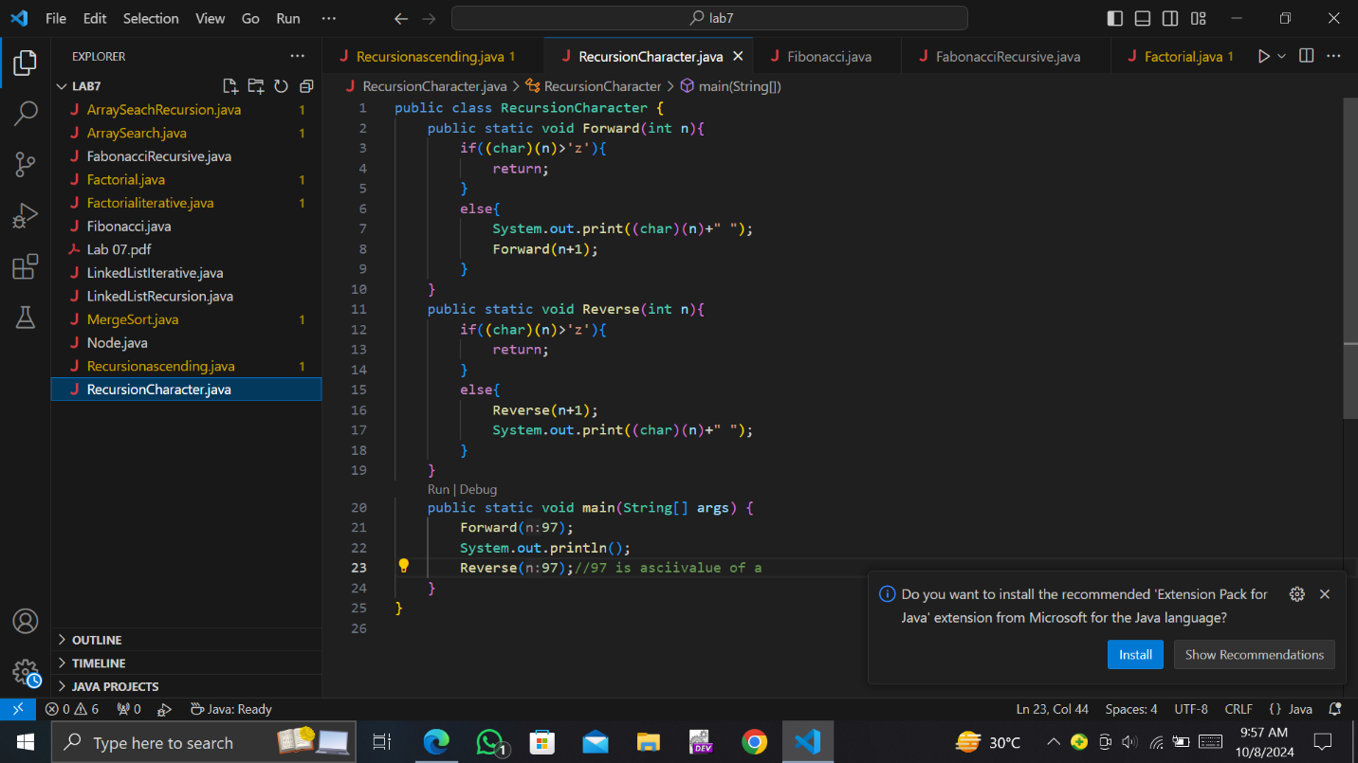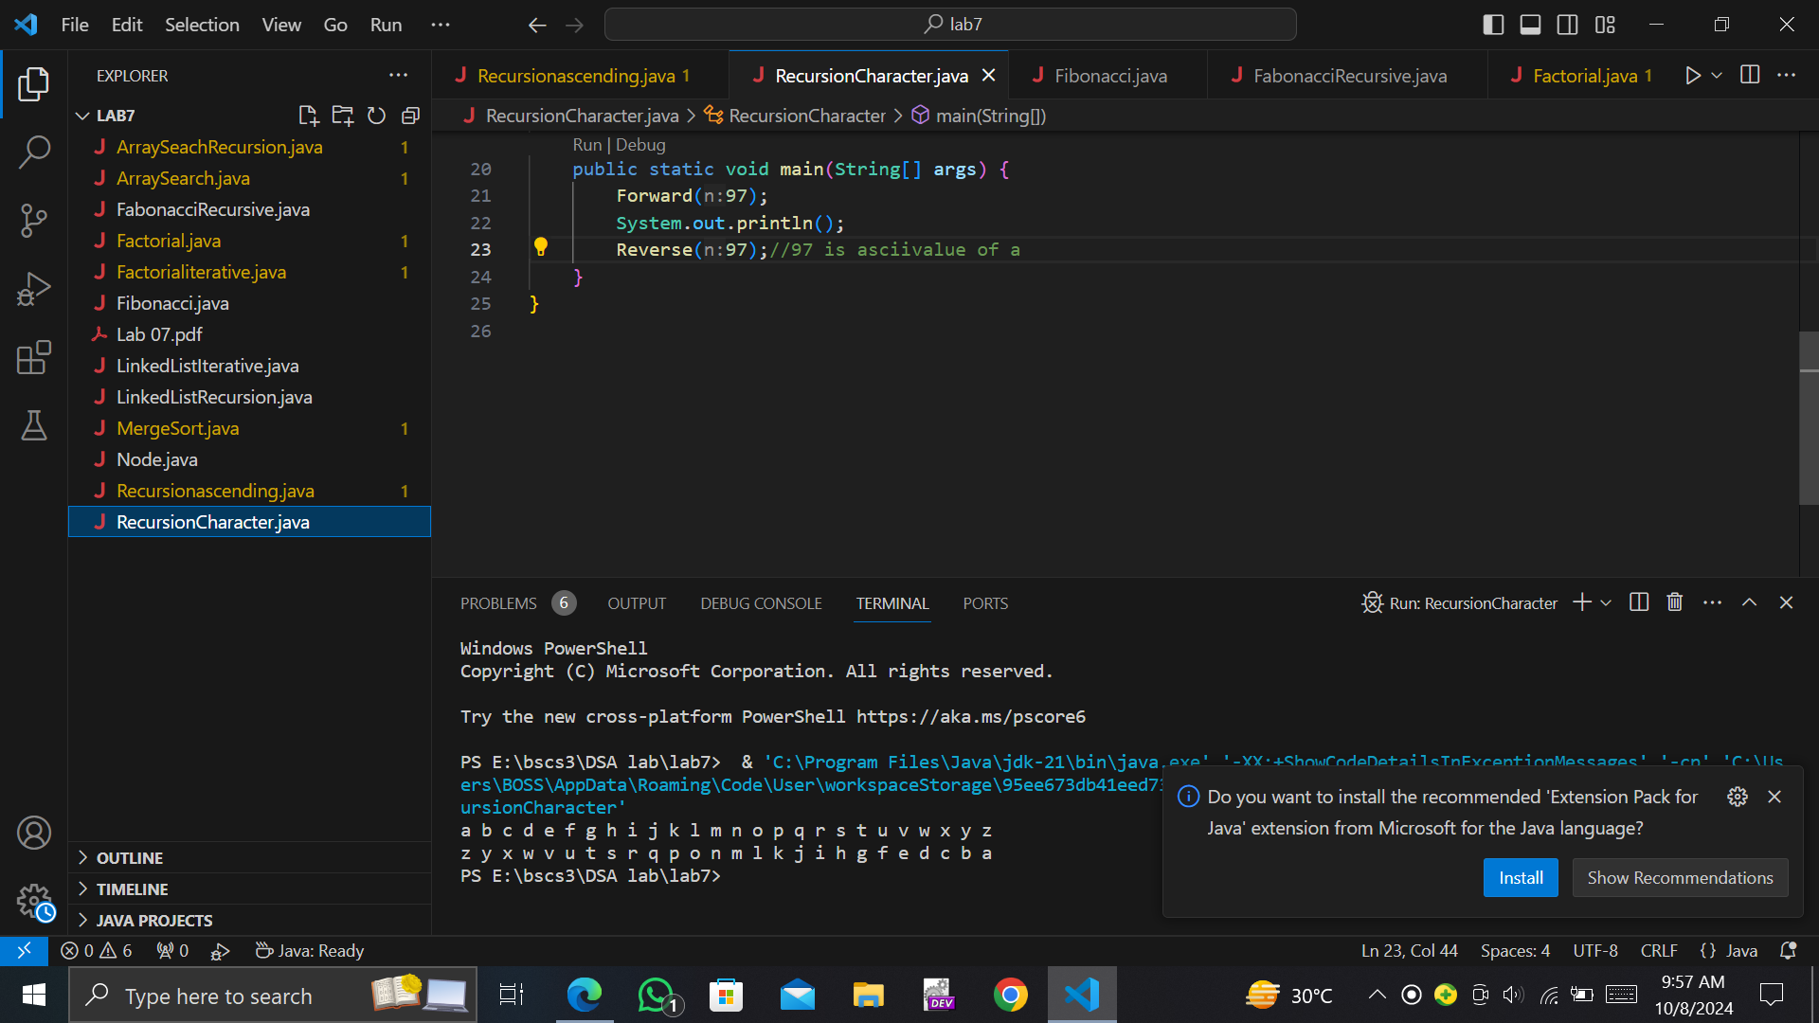

**Task #3(a)**

**Merge Sort**

**Solution:** 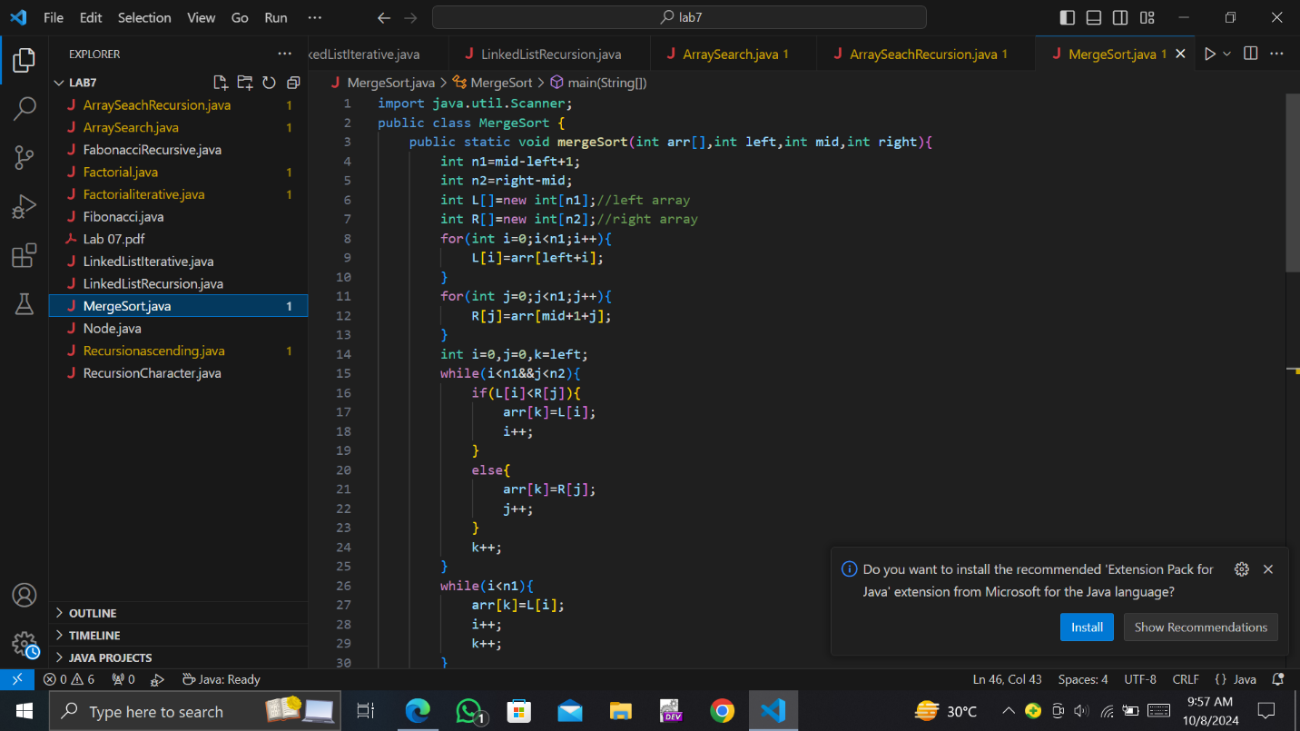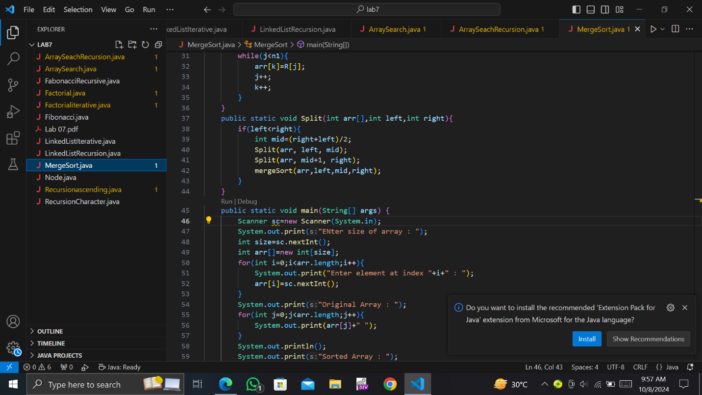

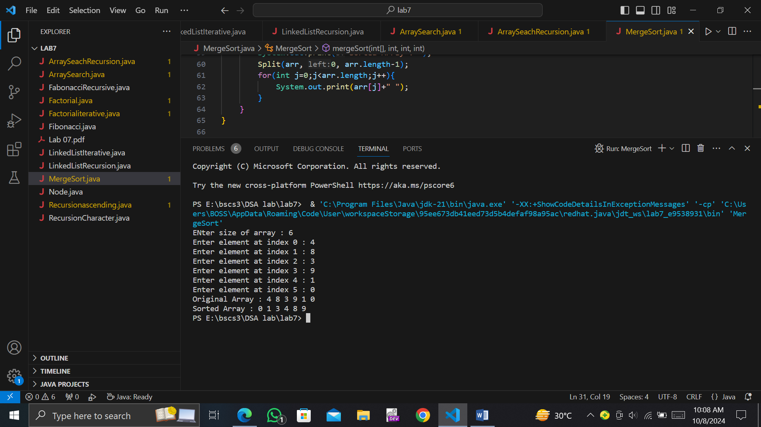

**Task #4**

. Write a program to generate Fibonacci series till N. N is any user input

. a) Using iterative approach and calculate time.

**Solution:**

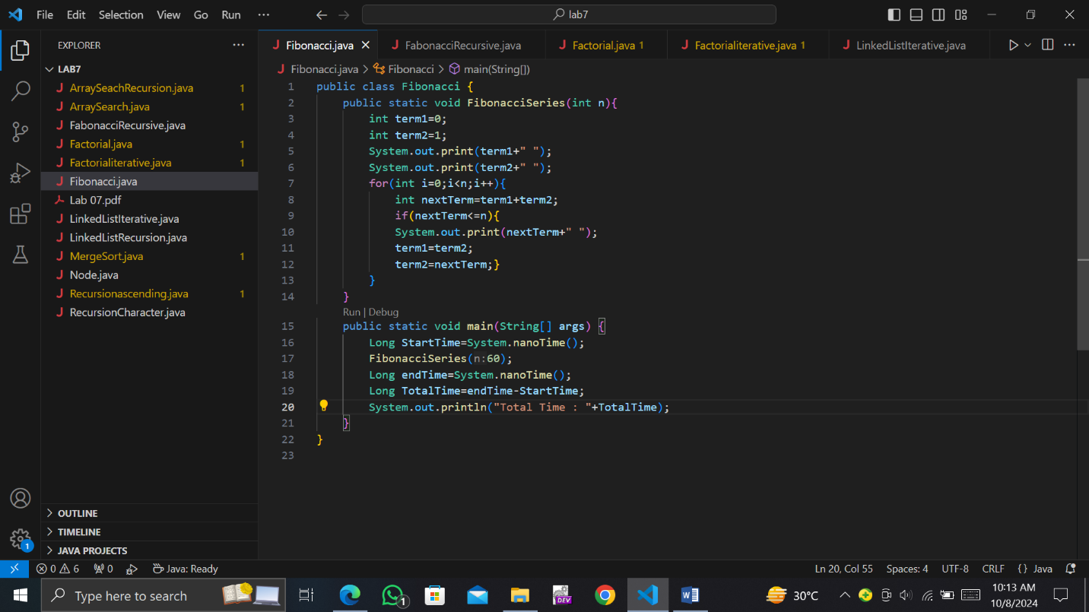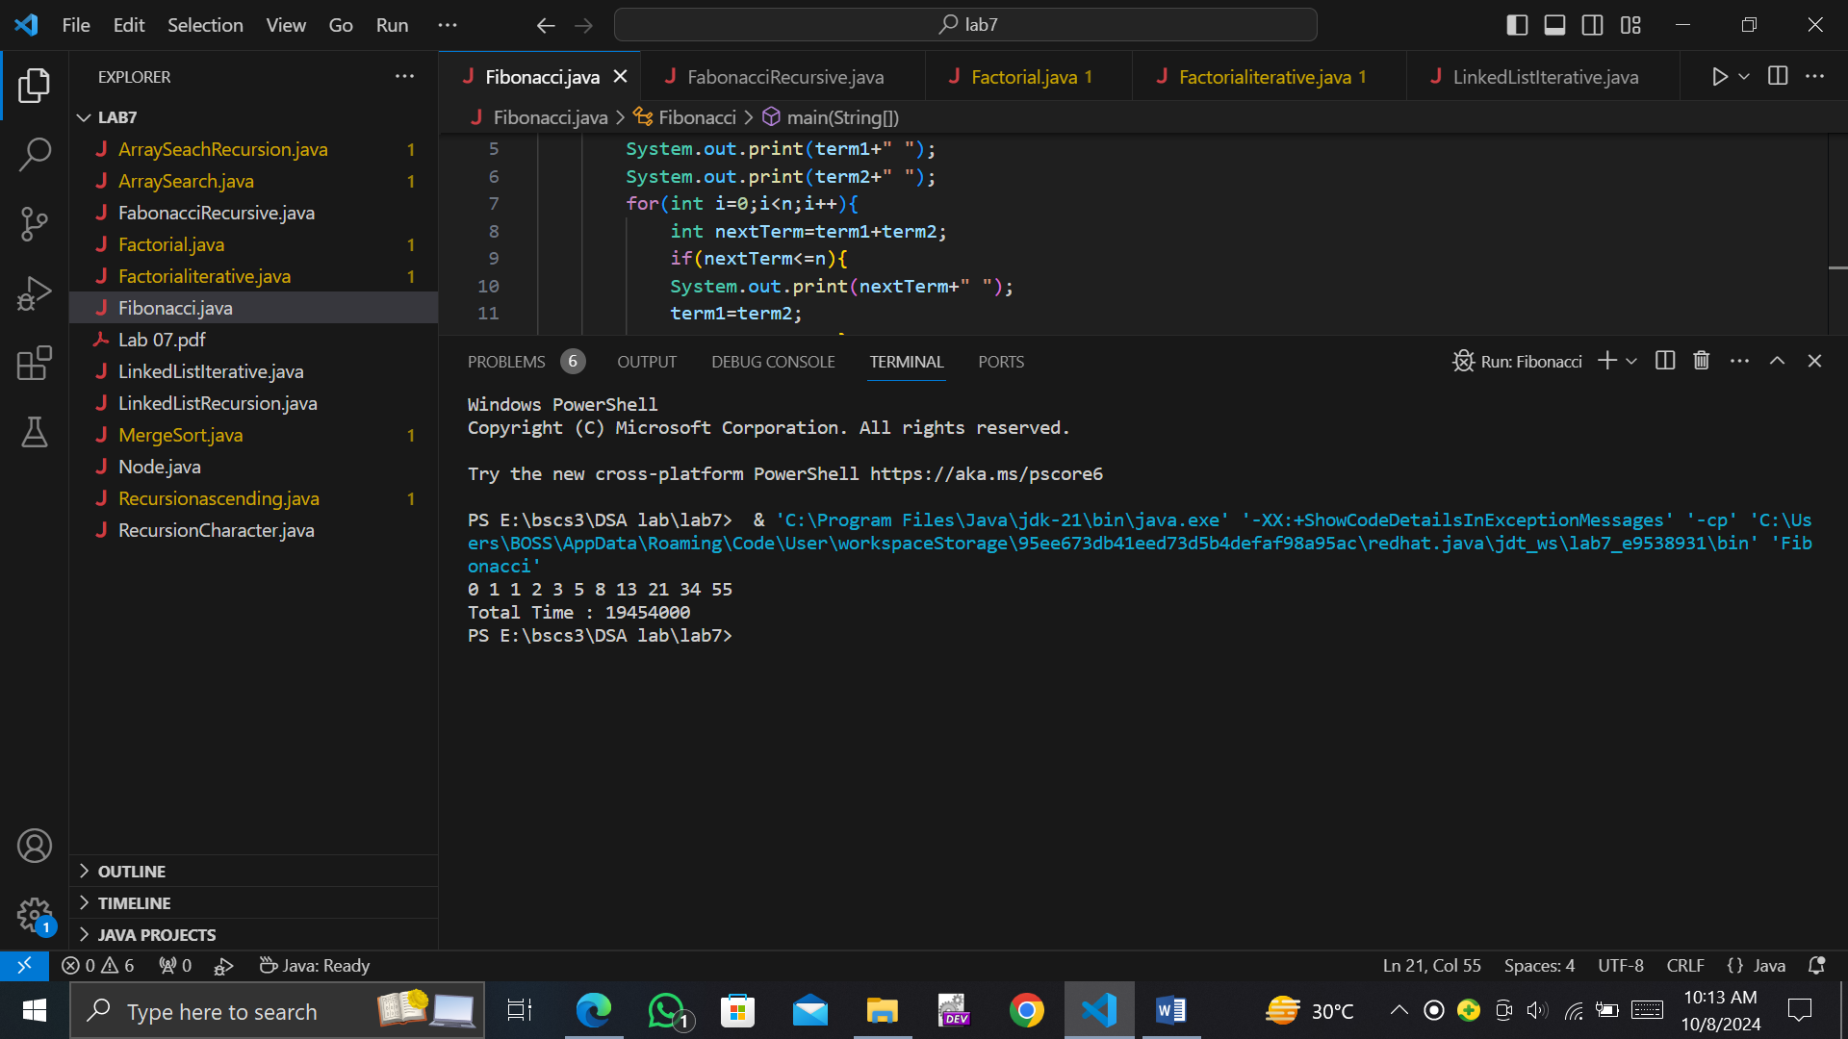

. Write a program to generate Fibonacci series till N. N is any user input

. b) Using recursive approach and calculate time.

**Solution:**

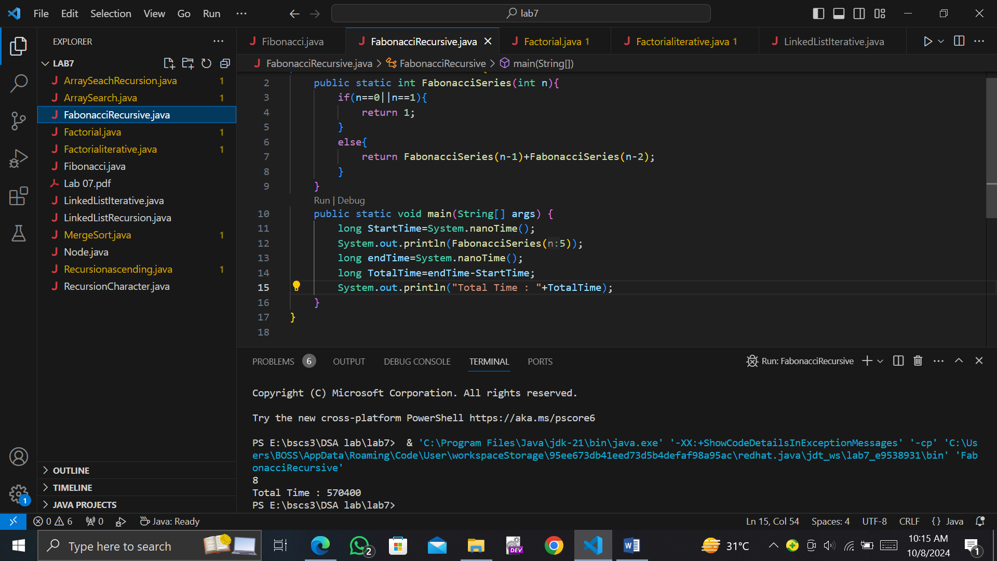

**Task #5**

Design a method to calculate factorial of N number where N is any user input.

a) Using iterative approach and calculate time.

**Solution:**

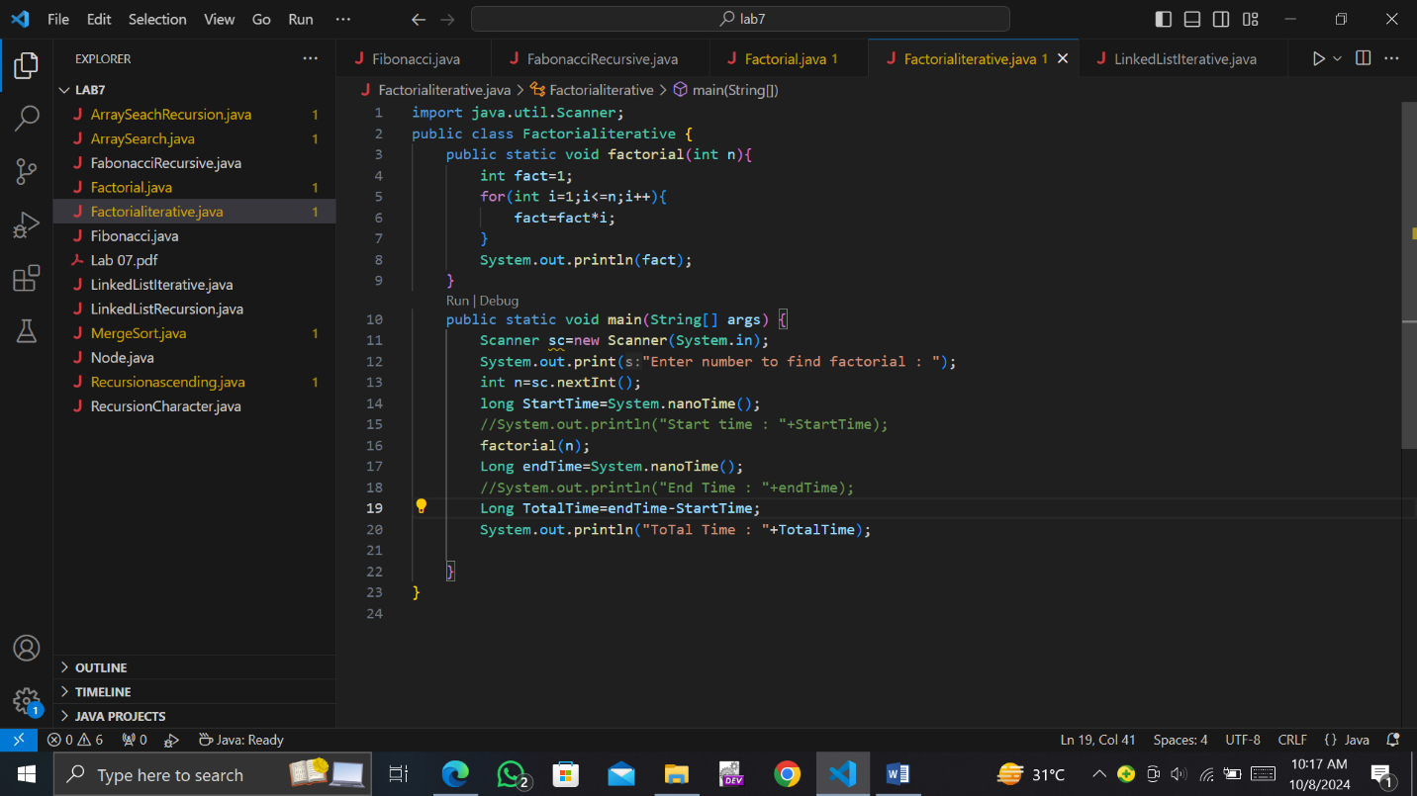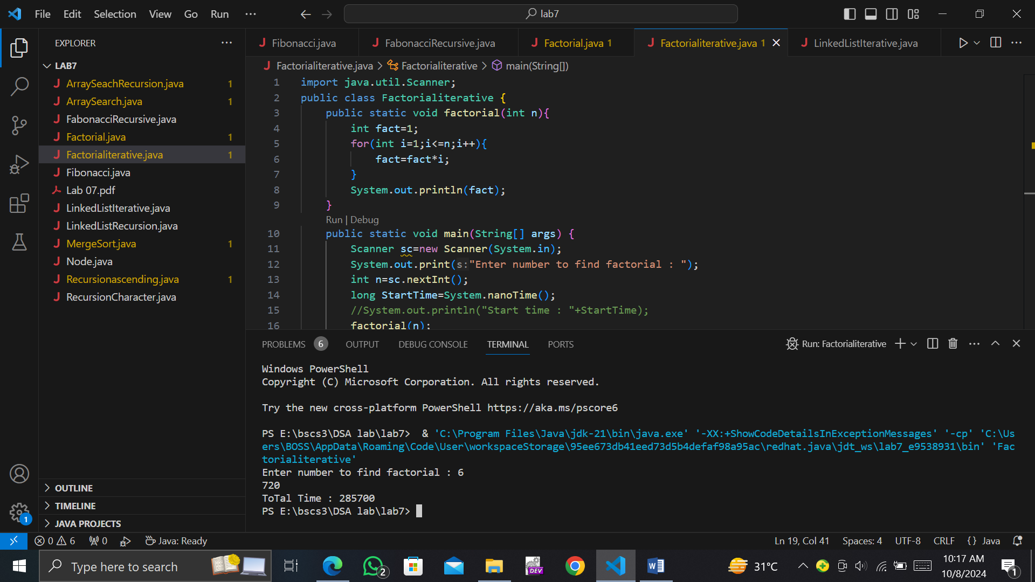

Design a method to calculate factorial of N number where N is any user input.

b) Using recursive approach and calculate time.

**Solution:**

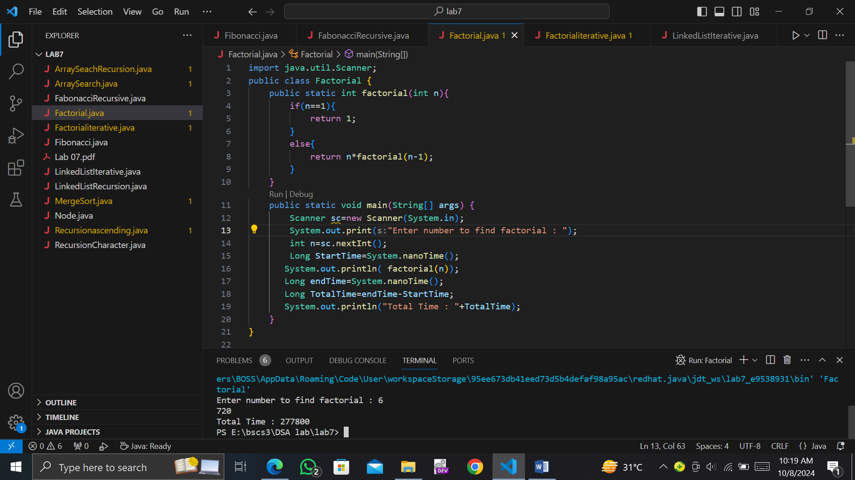

**Task #6**

Write a program to print all nodes from linked list

a) Using iterative approach and calculate time.

**Solution:**

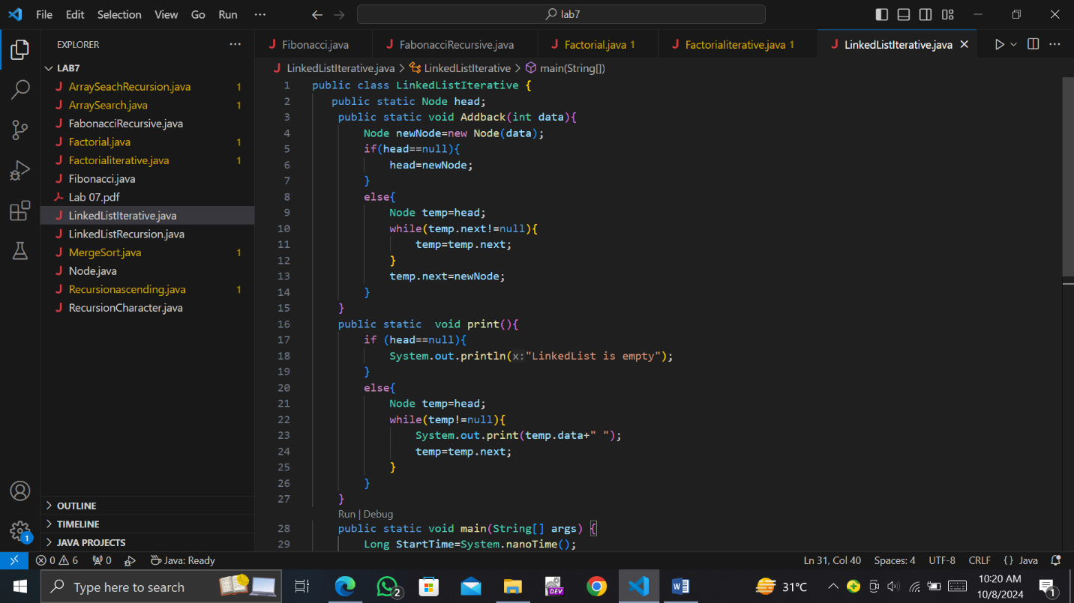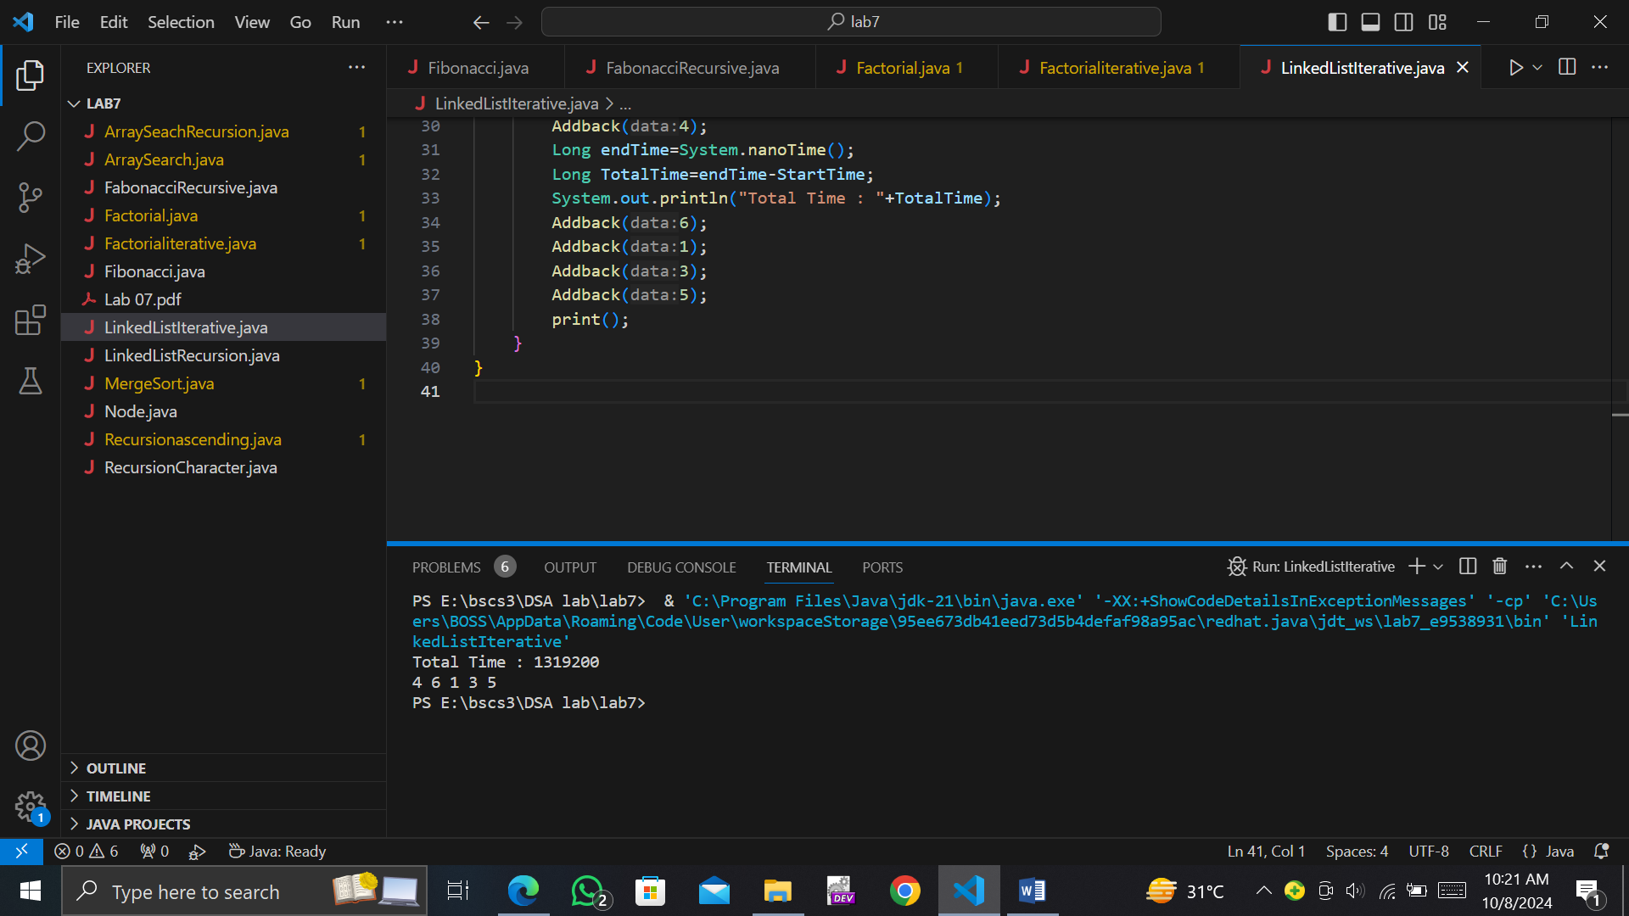

Write a program to print all nodes from linked list

b) Using recursive approach and calculate time.

**Solution:**

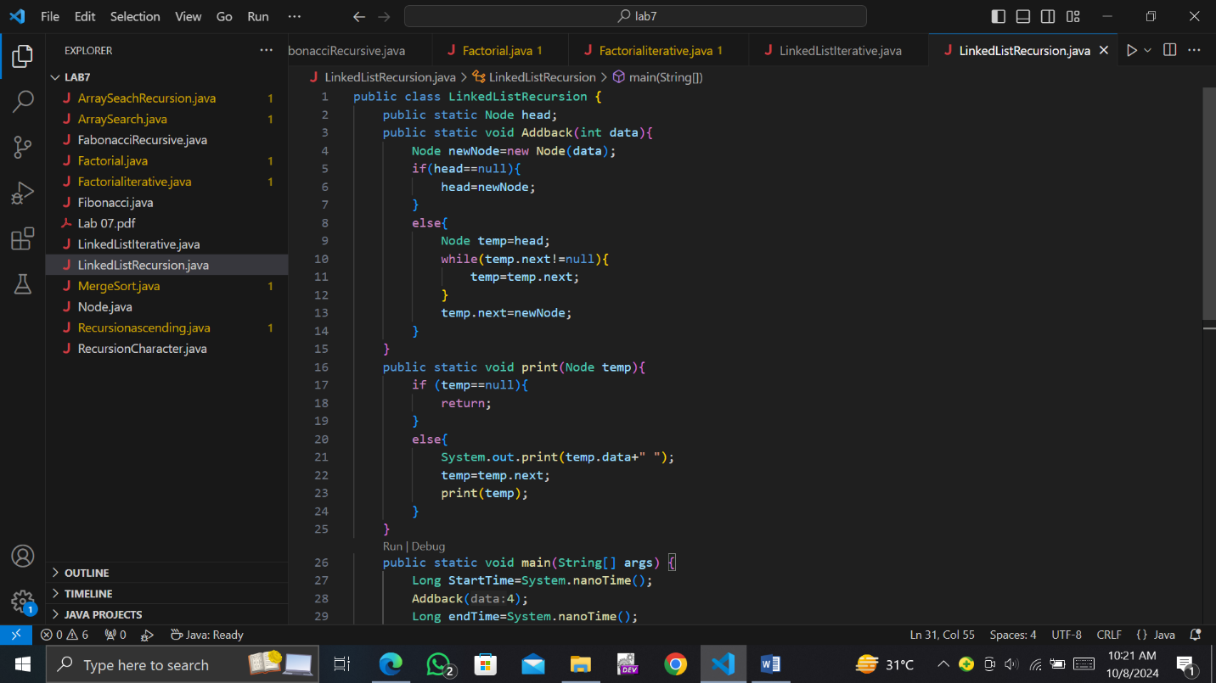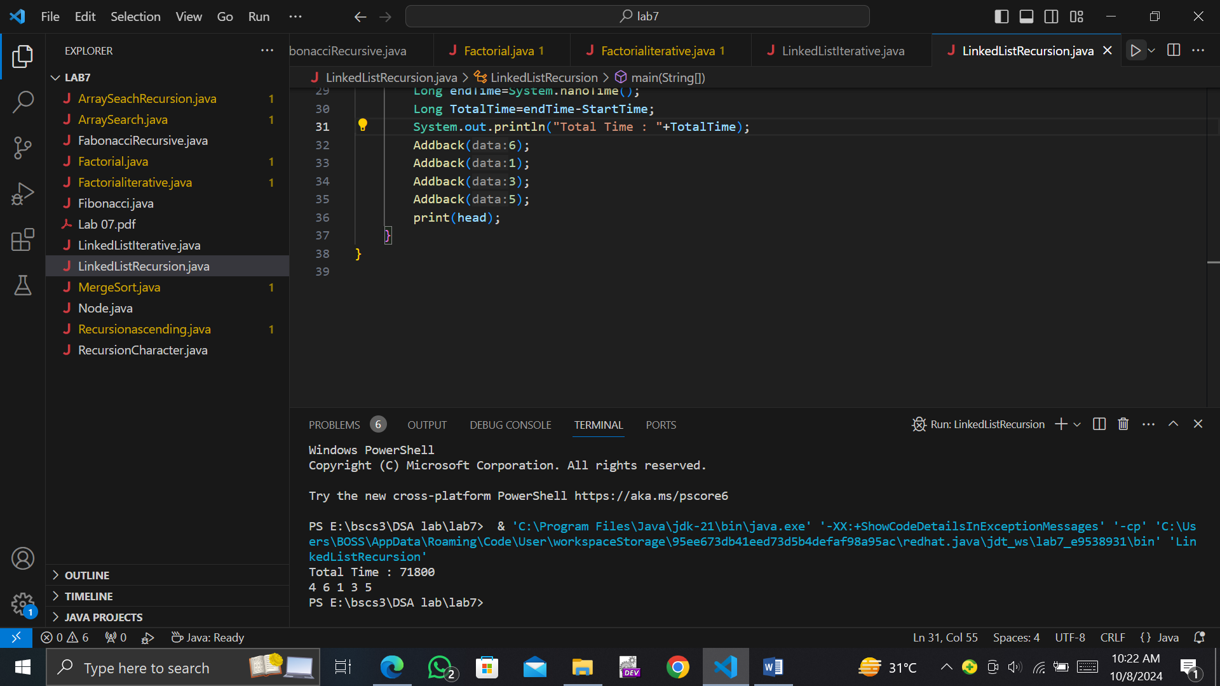

**Task #7**

Write a program to store random values in array of integers and ask user any input Search, find out whether Search value is present in array or not. If present, then return 1 otherwise 0.

1. Using iterative approach and calculate time.

**Solution:**

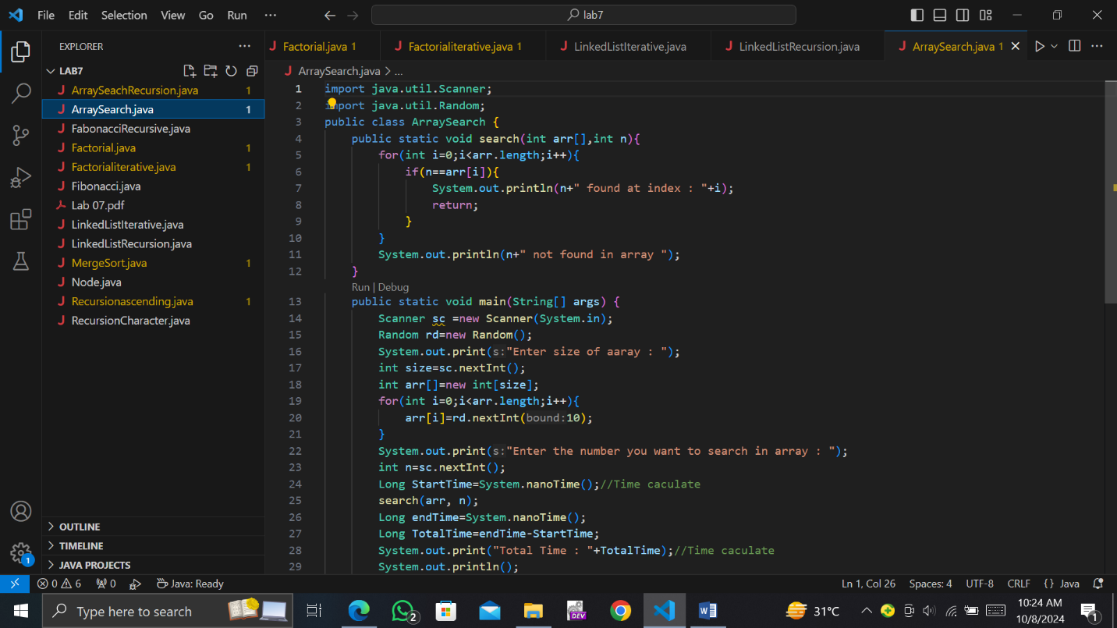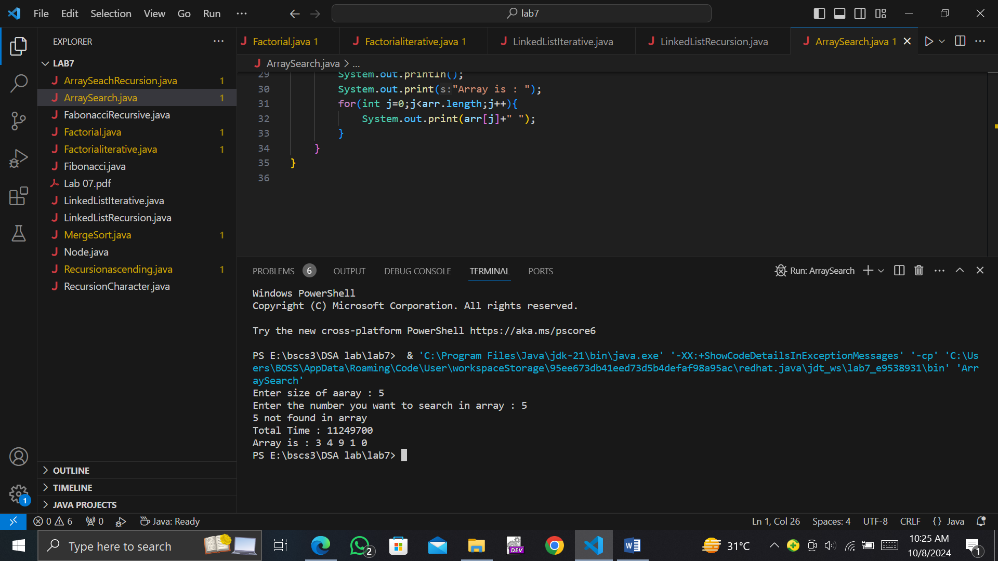

Write a program to store random values in array of integers and ask user any input Search, find out whether Search value is present in array or not. If present, then return 1 otherwise 0.

1. Using recursive approach and calculate time.

**Solution:**

